Architecture Design Document

Project: DBSentry File Sync
Project Leader: Jeetendra Prasad

- Document Status Sheet

Issue | Revision | Date | Reason
0 | 0 | 8th Sep 2004 | Creation

- Document Change Record

Section | Summary of changes

- Abstract
This document records the Architectural Design for DBSentry File Sync. DBSentryFileSync is a file synchronization application. It allows two replicas of a collection of files and directories to be stored on different hosts, modified separately, and then brought up to date by propagating the changes in each replica to the other.
Currently the supported file systems are cmsdk and UNIX. It will be implemented using client-server architecture. And they will communicate using JXTA. The server will decide the file system to which client can connect. This way it gives one point control to the administrator to switch between different file systems. Since it is implemented using JXTA, the location of server need not be fixed and client need not know, where server is located. It provides secured communication between the client and the server.

The responsible team consists of Mr. Jeetendra Prasad.

- Table Of Contents:
  - Introduction
    - Purpose
    - Scope
  - System Overview
    - Basic Design and Context
      - Server
      - Client
  - Design Decisions and Preliminary information
    - Platform
    - Technology
    - User Interface
  - System Design
    - Design Method
    - Decomposition Description
      - Server
      - Client

1 Introduction
This section describes the purpose and the scope of this document. Also the definitions, acronyms and abbreviations used in this document are described in this section. The last two parts of this section contain references and an overview of the entire document.

  - Purpose
The ADD provides a beginning of a solution - by means of component decomposition - for all software requirements specification defines a basic object model specifying the components and interfaces between components within the User Interface and the DBSentry File Sync programs, which are developed during the project.

  - Scope
DBSentry File Sync is a software product being developed by DBSentry Solutions Pvt. Limited. The ADD describes the Architectural Design for the User Interfaces and various other Modules. The DBSentry File Sync product is designed using an object orientated design method.

2 System Overview
This section briefly discusses the system context and basic top-level design, design decision etc. The architectural design is further documented in chapter 3.

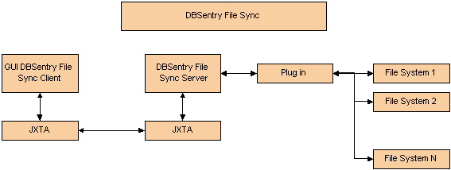

Figure 2.1f

Features of DBSentryFileSync:
- Since developed in java, it can be run on any operating system.
- It uses JXTA as transport protocol.
- Transfer of data in a secured way. Using secured socket.
- It user advanced algorithm to compare document for their difference in content.
- Will make the file system transparent to the client.
- it uses plug in to serve different file system. So adding new file system will be as simple as copying the jar file in the class path and modifying configuration file.
- The server will run as a service in the background
- Easy to use client interface
- It is resilient to failure. It is careful to leave the replicas and its own private structures in a sensible state at all times, even in case of abnormal termination or communication failures.

- 1 Basic Design and Context:
At the top level of the system, we can distinguish two major parts.

2.1.1 Server
The server also starts by first initializing the JXTA. This is necessary to start JXTA communication. This is one time operation. Then we are provided with the option to select a file system to server. This is also one time operation. Latter it can be changed by modifying the configuration file and restarting the server. The switching of file system will be done using plug in so that addition of new file system is easy. The server can be made to run as a service.

Features of the server
- Developed using java
- It will run as a service in the background
- Will make the file system transparent to the client
- It uses simple configuration file to define various parameter
- It uses plug in to serve different file system. So adding new file system will be as simple as copying the jar file in the class path and modifying configuration file

2.1.2 Client
The client starts by initializing JXTA, as it is necessary for starting JXTA communication with the server. Then it provides user with a screen to login to the server. On successful authentication it displays the list of files and folder in the user’s home folder on both the system i.e. the client and the server. User can navigate in the directory structure of both the file system depending on his rights. Then he can select the files and the folder to synchronize. He can select the option based on which he wants to compare and synchronize the file like modification date and content. If the system cannot decide which file will be transferred to which side then he is provided with option to decide what system should do. For example, suppose he decides to compare the files for difference in content. And he finds a list of files whose content are not same. Then he can decide which file to transfer on which side.
Features of the client:
- Developed using java
- Secured login using user id and password
- It will display the file system of client and server
- User can perform all the navigation operation like forward, backward, up, go to a given folder etc. on both, the client and the server
- Select files and folder to compare based on different option like date and content. And then they can be synchronized.
- Uses advanced algorithm to compare file for content change. So that you do not compare byte by byte.
- Easy to use interface
- The client can also sit in the system tray.
- User can specify some files/folders on the client, and these files are backed up on the server side (We can zip all the files/folders on the client into one file and then move this file to the server's backup area).
- User should be able to define the frequency with which this backup jobs should run

2.1.3 GUI Front-end Server
No Gui
2.1.4 GUI Front-end Client

To be designed

2.2 Design Decisions and Preliminary information:
2.2.1 Platform: It is designed in java so it is platform independent.
2.2.2 Technology: The system is to be developed using Java and JXTA as transport
protocol.
2.2.3 User Interface: All the user interfaces will be developed using Java Swing.

3. System Design

This section describes the method used for the decomposition of the system and gives a short description of the system components.

  - Design Method:
The method used to design the component model is [OMT]. The model is made with [UML]. The presented model is a decomposition view into components. A top-down approach is used to decompose the system.

  - Decomposition Description:
At the top level of the system, as mentioned in figure 2.1f, two major parts can be distinguished. These are:
4.2.1 Server
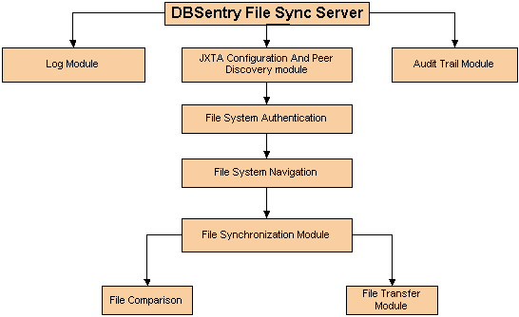

Figure 4.2.1a (Server)

As described in figure 4.2.1f the Client module shall have following sub-modules.
- JXTA Configuration and discovery Module: This module will configure
the JXTA to start JXTA communication. JXTA is a peer to peer protocol.
The first time a JXTA technology application is run, an auto-configuration tool JXTA Configurator) is displayed to configure the JXTA platform for your network environment. This tool is used to specify configuration information for TCP/IP and HTTP, configure rendezvous and relay peers, and enter a user name and password. When the JXTA Configurator starts, it displays the Basic Settings panel (see Figure 6-3). Additional panels are displayed by selecting the tabs (Advanced, Rendezvous/Relay, Security) at the top of the panel.
Basic: You can use any string for your peer name. If your peer is located behind a firewall, you will also need to check the box "Use a proxy server" and enter your proxy server name and port number2.
Advanced: This panel is used to specify TCP and HTTP settings. Outgoing TCP connections should be enabled for most situations. If you are not behind a firewall or NAT, incoming TCP connections should also be enabled, and you do not need to use a relay. If you are behind a firewall or NAT, incoming connections should be disabled and a relay is needed in order to communicate.
Rendezvous/Relay: Download the list of rendezvous and relay peers. If you are
behind a firewall or NAT, select Use a Relay.
Security: Enter a username and password.

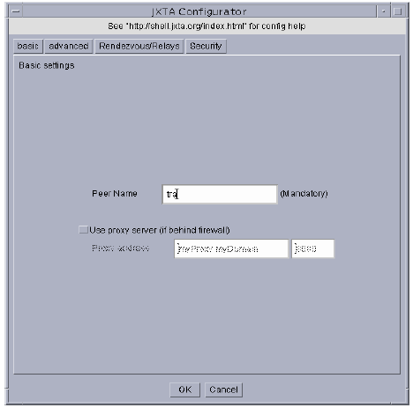
Configuration information is stored in the file ./.jxta/PlatformConfig; security information (username and password) is stored in the ./.jxta/pse subdirectory. The next time the application runs, this information is used to configure your peer. If you would like to re-run the auto-configuration tool, create a file named reconf in the ./.jxta directory. If this file exists when you start your JXTA application, the JXTA configurator will run and prompt you for new configuration information. (You can also remove the PlatformConfig file and then start your application again; The JXTA Configurator runs if there is no PlatformConfig file.)

When JXTA configuration is over then it advertises its existence in the network. The server is identified by a unique id.
- User Authentication module: This module accepts the user id and the
Password and verifies against the file system.

- Navigation module: This module allows the users to navigate and search for files and folder in the file system. Various Navigation that can be performed are
- Show content of a given folder
- Show content of a given folder
- Show the content of the parent of a given folder
- Move back in the recent navigation history
- Move forward in the recent navigation history
- File Synchronization Module: It allows two replicas of a collection of files and directories to be stored on different hosts, modified separately, and then brought up to date by propagating the changes in each replica to the other. Before synchronization file are compared on various option like
    - Date
    - Content
It uses advance algorithm to compare file for their difference in content
- File Comparison Module: It compares files to find out if it has changed. The file is said to have changed if
    - Modified date has changed
    - Content has changed.
If modified date has changed but content has not changed, in that case we need not transfer the files. We can also compare the file asymmetrically and within sub folder. Comparing file asymmetrically means that we compare a set of file or folder on one side with the other side but not other way.
- File Transfer Module: Transfers the file from one side to other
- Logger Module:
  - Provides logging facility to the application.
- Audit trail Module : Records user activity on the DBSentry File Sync Client

    - Client

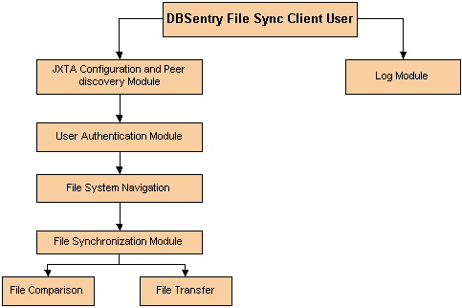

Figure 2.2.2a (Client)

As described in figure 4.2.2f the server module shall have following sub-modules.
- DBSentry File Sync Client User: This is the use who has account in the remote file system to which he wants to connect

- JXTA Configuration And Peer Discovery Module: To start JXTA communication you need to start and configure JXTA as done for the server. Then a discovery message is sent to find the server
- User Authentication Module: It get the user id and password of the user and sends it to the server for validation
- File system navigation module: This module send the request to the server to perform various navigation operations. Like
        - Show content of a given folder
        - Show content of parent folder
        - Move back in the navigation history
        - Move forward in the navigation history
- File Synchronization Module: It allows two replicas of a collection of files and directories to be stored on different hosts, modified separately, and then brought up to date by propagating the changes in each replica to the other. Before synchronization file are compared on various option like
    - Date
    - Content
It uses advance algorithm to compare file for their difference in content
- File Comparison Module: It compares files to find out if it has changed. The file is said to have changed if
    - Modified date has changed
    - Content has changed.
If modified date has changed but content has not changed, in that case we need not transfer the files. We can also compare the file asymmetrically and within sub folder. Comparing file asymmetrically means that we compare a set of file or folder on one side with the other side but not other way.
- File Transfer Module: Transfers the file from one side to other
- Logger Module:
  - Provides logging facility to the application

Various operations that can be performed by DBSentry File Sync client are:
- Connect
- Disconnect
- Display Content of a given folder
- Navigate back in the navigation history
- Navigate forward in the navigation history
- Cut document or folder
- Copy document or folder
- Paste document or folder
- Delete document or folder
- Compare selected file
- Send file
- Receive file

